**Wireless power transfer system:**

**Introduction:**

The Wireless Power Transfer (WPT) system is based on the law of electromagnetic induction, discovered by Michael Faraday in the early 19th century. This law states that a changing magnetic field induces an electromotive force (EMF) in a coil of wire. The EMF causes a current to flow in the coil, which can be used to power an electrical load. In the case of WPT, the changing magnetic field is generated by the transmitter coil, and the EMF is induced in the receiver coil. The magnitude of the induced EMF depends on the rate of change of the magnetic field and the number of turns in the receiver coil. By controlling the strength and stability of the magnetic field, the WPT system can be designed to transfer energy efficiently from the transmitter to the receiver

**Components Used:**

* Transistor 2N222A
* Resistor 27k
* Battery 9v
* Hook up wires
* Switch
* Receiver Coil
* Transmission coil
* Light Emitting Diode (LED)

**Principle of Wireless Power Transfer:**

The principle of Wireless Power Transfer (WPT) system is based on the transfer of energy through electromagnetic fields. The system typically consists of a power source, a transmitter, a transmission coil, a receiver coil, a rectifier circuit, and a load.

1. The power source converts electrical energy into an alternating current (AC) signal.
2. The transmitter takes the AC signal and applies it to the transmission coil, which generates a magnetic field around it.
3. The magnetic field extends from the transmission coil to the receiver coil, which is positioned near the load.
4. The magnetic field induces a current in the receiver coil, which is then rectified by the rectifier circuit into a direct current (DC) signal.
5. The DC signal is then used to power the load.

This process of transferring energy through an electromagnetic field is known as electromagnetic induction. The efficiency of the Wireless Power Transfer is largely dependent on the strength and stability of the magnetic field, as well as the distance between the transmitter and receiver coils. To improve the efficiency of the system, some WPT technologies use resonant or microwave systems, which are designed to maximize the amount of energy that is transferred.

**Application:**

1. Wireless power transfer system can be used to charge smartphones, tablets, and other portable devices without the need for cords or plug-ins.
2. Electric vehicles: WPT can be used to charge electric cars, reducing the need for charging cords and stations.
3. Medical devices: WPT can be used to charge and power implantable medical devices, such as pacemakers and insulin pumps.
4. Industrial automation: WPT can be used in industrial settings to transfer power to moving equipment, such as robots and conveyor belts.
5. Home appliances: WPT can be used to charge and power home appliances, such as televisions, lights, and air conditioners.

**Conclusion:**

wireless power transfer systems have the potential to revolutionize the way we transfer and use energy. This project aimed to explore the capabilities and limitations of wireless power transfer technology, and to contribute to the ongoing efforts to advance the field.

The results of this project have shown that wireless power transfer can be an efficient and effective method for transferring energy, with numerous potential applications. However, there are still many challenges to overcome, such as increasing the range and efficiency of wireless power transfer, and ensuring that it is safe and reliable for use in various environments.

**Circuit Diagram:**

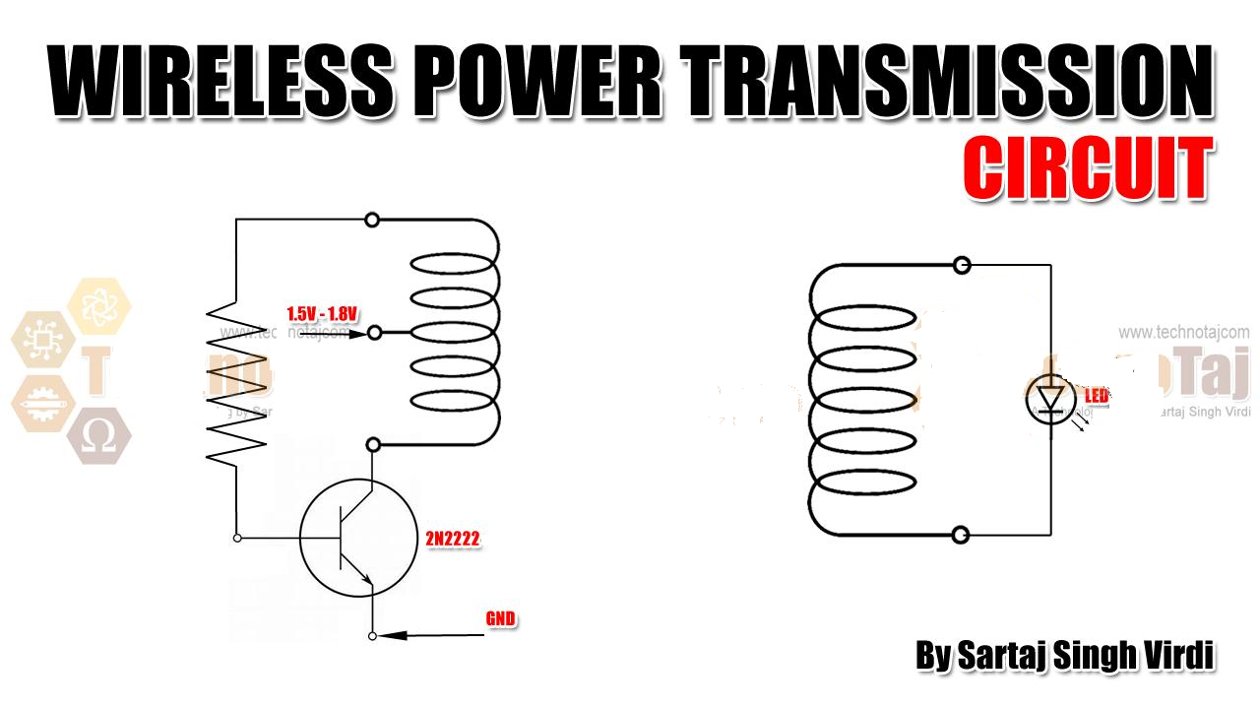

Source*:* ***https://www.technotaj.com/2020/11/30/tesla-reborn-wireless-power-transmission-school-project/***